
City of Moreno Valley
Community Development Department
Planning Division
City Hall Council Chamber
14177 Frederick Street
Moreno Valley, CA 92553

NOTICE OF PUBLIC HEARING (VIA TELECONFERENCE ONLY)
PURSUANT TO COVID-19 GOVERNOR EXECUTIVE ORDER N-29-20
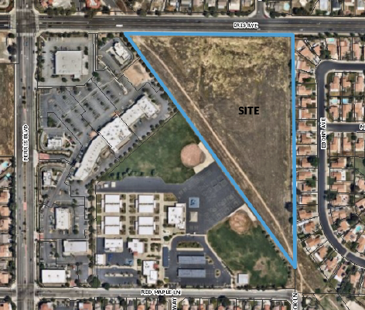
Notice of Teleconferenced Public Hearing before the Planning Commission of the City of Moreno Valley:
DATE & TIME: November 12, 2020 at 7:00 P.M. VIA TELECONFERENCE ONLY
COVID-19 TELECONFERENCE INSTRUCTIONS:
For Teleconference Meeting public participation instructions please see agenda at http://morenovalleyca.iqm2.com/Citizens/default.aspx
PROJECT LOCATION: South side of Iris Avenue east of Perris Boulevard (312-020-025)
CASE NUMBER(s):
PEN20-0063 and PEN20-0065-0066
CASE PLANNER: Julia Descoteaux, Associate Planner (951) 413 3209 or juliad@moval.org
<APN>
<Property Owner>
<Street Address>
<City, State, Zip>
NOTICE OF PUBLIC HEARING
PROPOSAL: The applicant proposes to develop an approximately 10.82-acre site for a Tentative Tract Map 37909 for an 81-lot subdivision including a Conditional Use Permit for a Planned Unit Development. The site is zoned Residential 5 (R5) with a General Plan designation of Residential 5 (R5). Applications for a General Plan Amendment and Change of Zone are included to change the General Plan designation to Residential 10 (R10) and the Zoning designation to Residential Single-Family 10 (RS10), which would allow the proposed development.
ENVIRONMENTAL DETERMINATION: The City of Moreno Valley has reviewed the above project and has prepared an Initial Study in accordance with California Environmental Quality Act (CEQA) Guidelines Section 15070. The Mitigated Negative Declaration represents the City’s independent judgement and analysis. The proposed project will not have a significant effect on the environment with the implementation of mitigation measures.
PUBLIC HEARING: All interested parties will be provided an opportunity to submit oral testimony during the teleconferenced Public Hearing and/or provide written testimony during or prior to the teleconferenced Public Hearing. The application file and related environmental documents may be inspected by appointment at the Community Development Department at 14177 Frederick Street, Moreno Valley, California by calling (951) 413-3206 during normal business hours (7:30 a.m. to 5:30 p.m., Monday through Thursday).
COVID-19 – IMPORTANT NOTICES: Please note that due the COVID-19 pandemic situation, staff will attempt to make reasonable arrangements to ensure accessibility to inspect the aforementioned records. In addition, special instructions on how to effectively participate in the teleconferenced Public Hearing, as approved by Governor Executive Order N-25-20, will be posted at http://morenovalleyca.iqm2.com/Citizens/default.aspx and will be described in the Planning Commission agenda.
PLEASE NOTE: The Planning Commission may consider and approve changes to the proposed items under consideration during the teleconferenced Public Hearing.
GOVERNMENT CODE § 65009 NOTICE: If you challenge any of the proposed actions taken by the Planning Commission in court, you may be limited to raising only those issues you or someone else raised during the teleconferenced Public Hearing described in this notice, or in written correspondence delivered to the Planning Division of the City of Moreno Valley during or prior to, the teleconferenced Public Hearing.

